COS30018 – Intelligent Systems
Project Assignment Report
Assignment Topic 3

Team members:
Frederick Bartholomew Dao Xiang SII,104397146
Celester, 104398233
Nicholina, 104395470
Enoch Eren CHUA, 104401704

Contents
Introduction 3
Overall System Architecture 3
Data collection and annotation 3
Implemented machine learning techniques for people detection and fall recognition 3
Scenarios/examples to demonstrate how the system works, 3
Some critical analysis of the implementation 3
Practical application description 4
Summary/Conclusion 4
Presentation + demo video link 4
10. References 4

Introduction

Overall System Architecture

Fred’s Model Architectures
One-step
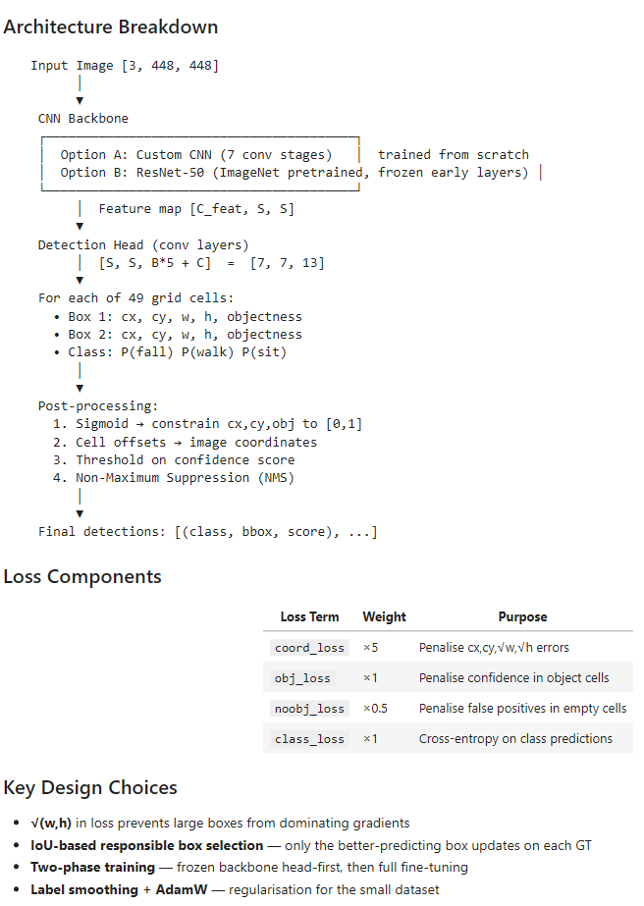

Data collection and annotation
## nicholina used LabelMe to label the test set
## Enoch webscraped 50 of each class of sit, walk and fall

Implemented machine learning techniques for people detection and fall recognition
##

Scenarios/examples to demonstrate how the system works
## sample images and detections, and why it detects

Some critical analysis of the implementation

Fred’s models
One-step
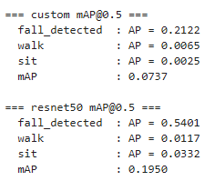
The custom convolutional neural network (CNN) solution employed by Frederick shows poor performance, likely due to not having enough samples to train and test with, or the samples are too visually similar. The poor performance is backed up by the above image, showing the Average Precision of two models trained: one custom CNN built from scratch, and the other a CNN transfer learning model based on ImageNet.
According to these statistics, the custom CNN model does not learn much at all, and only slightly detects falls, while completely failing at walk or sit. The transfer learning CNN model does not fare much better, however it does prove that transfer learning does indeed work, as it sees a 3x improvement over the custom CNN model.
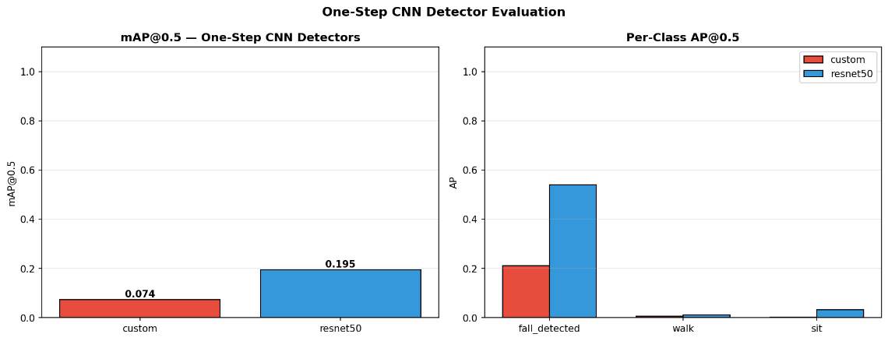
Overall, the two one-step models seem to be behaving as a binary classifier rather than a multi-class classifier, and this can be explained by viewing the above graph of the models’ average precisions for each of the classes, and we can tell that walk and sit is not being learned, if at all. As it stands, this model is correctly a “fall detector” but it is not a multi-class activity detector.

## qualitative analysis (images and why it always fails for example), quantitative analysis (statistics)
## some experiments

Practical application description

Summary/Conclusion
## example model is the best, because for example: it wins in every case study we do

Presentation + demo video link

References
Questions:

Architecture:
One step:
If fall == true
Return X or Y
Where X, Y = Mobile Net , YOLO models

Two step (feature extraction):
Person detection
Where x, y = mobile net, YOLO models
Then combine both to become one Two-step model
Permutations:
xY, yX, xX, yY
four total two-step models, then pick best performing to use.

